|  |  |
| --- | --- |
|  | Foundation Activity 11 Voltage Divider Nightlight |

Contents and Learning Outcomes

Students will use a voltage divider circuit to control an LED with a light-dependent resistor. This activity is intended to lay the foundation for discussing transistors. To this end, the nightlight circuit design is deliberately flawed.

This activity should take **~1 hour (1.5 hours is recommended)** to complete:

[Materials and Costs per Student 2](#_Toc531546789)

[Lesson 3](#_Toc531546790)

[Activity Overview (2 minutes) 3](#_Toc531546791)

[Voltage Divider (15 minutes) 3](#_Toc531546792)

[LED Properties (5 minutes) 4](#_Toc531546793)

[Light Dependent Resistor (LDR) (10 minutes) 5](#_Toc531546794)

[Building the Nightlight Circuit (20 mintues) 6](#_Toc531546795)

[Debrief Discussion (10 minutes) 6](#_Toc531546796)

[Challenge and Explore 8](#_Toc531546797)

[Frequently Asked Questions 9](#_Toc531546798)

Materials and Costs per Student

Assuming one kit of parts per student:

|  |  |  |  |  |
| --- | --- | --- | --- | --- |
| Item | Qty. | Cost per Student[1](#fn:1) | Expendable[2](#fn:2) | Supplier |
| LED, 5mm, white | 1 | 0.02 | y | AliExpress |
| Resistors, 1/4W, Assorted | 2 | 0.01 | y | AliExpress |
| 9V Battery Snap | 1 | 0.16 |  | AliExpress |
| Jumper cables, MM, 10cm | 4 | 0.08 | y | AliExpress |
| Light Dependent Resistor (LDR) | 1 | 0.05 |  | AliExpress |
| Breadboard 400 point | 1 | 1.49 |  | AliExpress |
| Breadboard Power Supply | 1 | 0.75 |  | AliExpress |
| 9V Ni-Mh 450mAh | 1 | 5.17 |  | AliExpress |
| Total Cost per Student |  | **$7.74 CAD** |  |  |

1. *Currency is CAD, 2017-06-10.*
2. *Likely to be broken or lost during the activity.*

Each student should also get one printed copy of the activity handout.

If running the activity in a room with daylight, I recommend using a 2.2kΩ resistor in the voltage divider with the LDR (see §Light Dependent Resistor). If running the activity in a fluorescent-lit room, use a 22kΩ resistor in the voltage divider. This will also depend on your light dependent resistor (LDR). The one used in this activity behaves as follows:

|  |  |  |
| --- | --- | --- |
|  | LDR Resistance | |
|  | **LDR Uncovered** | **LDR Covered with a Finger** |
| Daylight | 2.2kΩ | 20kΩ |
| Dusk | 10kΩ | 40kΩ |
| Fluorescent Lighting | 10kΩ | >50kΩ |

Experiment with the resistor values before the lesson to make sure the nightlight works in your light conditions. Having a bright LED flashlight in class to manipulate the LDR resistance is also advisable.

Lesson

**Bold text** indicates directions or notes specifically for the instructor.

Activity Overview (2 minutes)

In the last activity we made a lock box, where pressing a button would lock or unlock the box by causing a servo motor to rotate. The button was a digital input to the Arduino microcontroller board, and used a pull-down resistor to give a clear HIGH or LOW digital value to the Arduino. The Arduino then sent a control signal to the servo motor so that it would rotate to a specific degree.

Today, we’re going to use a light sensor to make a nightlight – a light that turns on automatically when the room becomes dark, then turns off again when the room is bright.

Voltage Divider (15 minutes)

|  |  |
| --- | --- |
| Ohm’s Law relates current, voltage and resistance. From the equation we can see that when current passes through a resistance, voltage drops across the resistance. W**rite out the Ohm’s Law triangle, arrange for voltage, and write out the equation.** | Ohm’s Law  C:\Users\Harryp\MEGA\Surface Pro 2\Nepal\Himalayan Makers Guild\Activities\Foundation Activities\FA7 - Ohm's Law and Resistor Values\images\ohms.png |

If the current through the resistor stays the same, the voltage across the resistor will increase or decrease depending on its resistance.

When multiple resistors are in series, the amount of voltage that drops across one resistor depends on its resistance compared to the other resistors. If there are 5 equal resistors connected in series to a 5V battery, the 5V is dropped equally across them. Looking at the rockslide analogy of electricity **(draw the diagram on the board)**:

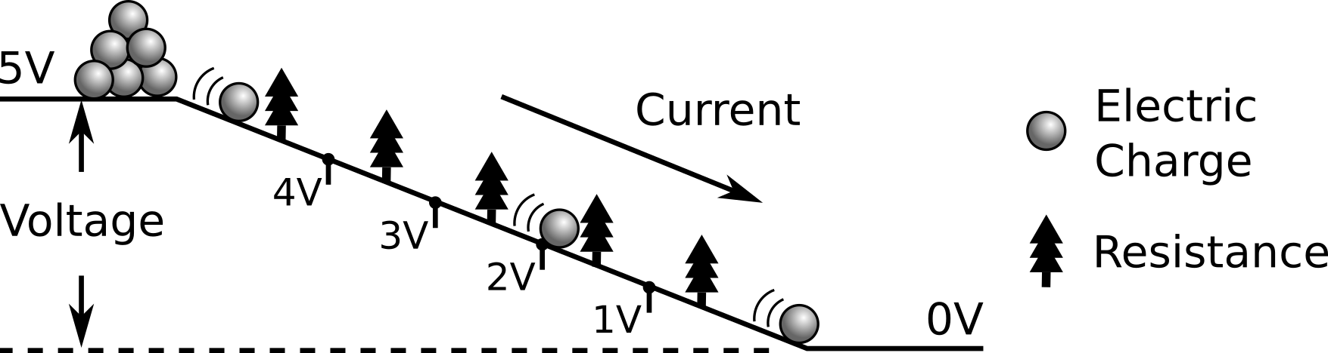

We can also draw this as a circuit diagram **(draw the diagram on the board)**:

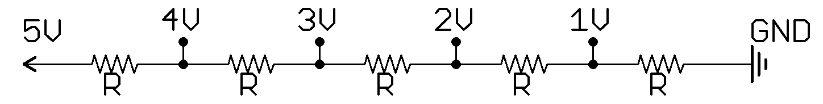

If we consider combining the five equal resistances a group of 2R and 3R **(draw the diagram on the board)**, then 2V is dropped across the 2R and 3V is dropped across the 3R.

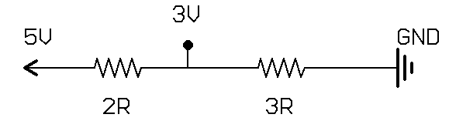

Similarly, if one resistance is R, and the other is 4R **(draw the diagram on the board)**, then the voltage will be divided between them as 1V and 4V respectively.

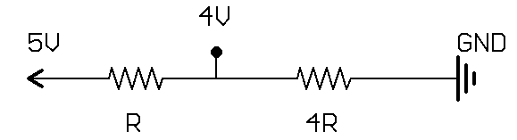

If two equal resistors are attached in series with a 5V battery, what is the voltage drop across each? A: 2.5 V

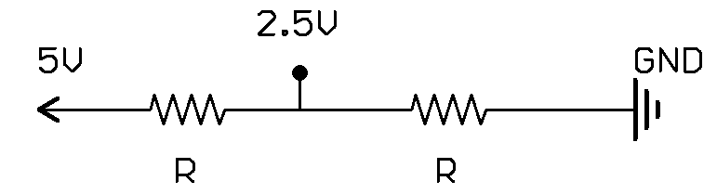

By controlling how the total resistance of the two resistors in series is divided, we can also control the division of voltage between them. This is called a voltage divider.

LED Properties (5 minutes)

When the voltage across a white LED is less than 3V, current cannot flow through it; it acts like a switch that is off. When the voltage across the LED is greater than 3V, current flows through it very easily, like a switch that is on. To help prevent high current from passing through the LED and burning it out, we use a resistor in series with the LED.

If we put 5 equal resistors in series, connected to a 5V battery, where could we connect the LED to make it turn on **(draw the circuit on the board)**?



A: at the 3V, 4V, and 5V point.

Light Dependent Resistor (LDR) (10 minutes)

An LDR changes resistance depending on how much light is shining on it.

|  |  |  |
| --- | --- | --- |
| In a bright room, the LDR will have a low resistance. | C:\Users\Harryp\MEGA\Surface Pro 2\Nepal\Himalayan Makers Guild\Activities\Foundation Activities\FA11 - Voltage Divider Night Light\images\Eagle\ldr10k.png | [[1]](#footnote-1) |
| In a dark room, the LDR will have a high resistance. | C:\Users\Harryp\MEGA\Surface Pro 2\Nepal\Himalayan Makers Guild\Activities\Foundation Activities\FA11 - Voltage Divider Night Light\images\Eagle\ldr50k.png |  |

With a voltage divider, we can control the voltage level between two resistors in series if we can control the resistance of one the resistors, then we can control the voltage level between them. Using this concept with a light dependent resistor we can turn an LED on and off automatically if the room becomes dark or light.

|  |  |  |
| --- | --- | --- |
| With two resistors in series as a voltage divider, we can control the voltage level between them (labeled here as Vout) and use it to turn on an LED when the room becomes dark. Should the top or bottom resistor be the LDR? Why? **(draw the diagram on the board)** | | A: The bottom resistor should be the LDR. When it becomes dark the resistance of the LDR becomes larger, so more of the 5V will drop across the LDR and Vout will become larger. |
| C:\Users\Harryp\MEGA\Surface Pro 2\Nepal\Himalayan Makers Guild\Activities\Foundation Activities\FA11 - Voltage Divider Night Light\images\Eagle\divider_R_R2.png | C:\Users\Harryp\MEGA\Surface Pro 2\Nepal\Himalayan Makers Guild\Activities\Foundation Activities\FA11 - Voltage Divider Night Light\images\Eagle\divider_R_LDR.png | |

By attaching an LED to Vout, it will act as a nightlight: **(draw the diagram on the board and illustrate the on/off behavior)**

|  |  |  |
| --- | --- | --- |
| Nightlight Circuit |  |  |
| C:\Users\Harryp\MEGA\Surface Pro 2\Nepal\Himalayan Makers Guild\Activities\Foundation Activities\FA11 - Voltage Divider Night Light\images\Eagle\nightlight.png | C:\Users\Harryp\MEGA\Surface Pro 2\Nepal\Himalayan Makers Guild\Activities\Foundation Activities\FA11 - Voltage Divider Night Light\images\Eagle\nightlight_off.png | C:\Users\Harryp\MEGA\Surface Pro 2\Nepal\Himalayan Makers Guild\Activities\Foundation Activities\FA11 - Voltage Divider Night Light\images\Eagle\nightlight_on.png |

We usually use a 220Ω resistor in series with the LED. Why don’t we need one in this circuit? A: the LED and LDR are in series with a 22kΩ resistor, so the current through the LED is already limited!

**Note: if you measure Vout in the ON state, it will be less than 3V. Since so little current is flows through the LED from the 22kΩ, it does not reach its full on-state voltage.**

Building the Nightlight Circuit (20 mintues)

**Distribute the parts to the students and have them try building the nightlight circuit.**

Debrief Discussion (10 minutes)

Today we used a Light Dependent Resistor in a voltage divider to turn an LED on and off automatically.

Was the voltage used to control the LED digital or analog?  
A: it is an analog value, because the voltage changes continuously depending on the light shining on the LDR.

Is there anything you would like to change about the light to make it a better nightlight?  
A1: the LED is pretty dim; it would be nice if it turned on brighter  
A2: adding a switch would give us more control to turn the light on and off. Sometimes you might not want the light on when the room is dark.

|  |  |
| --- | --- |
| Why is the LED so dim? A: (**draw the diagram on the board)** because the current has to flow through the large resistor in the voltage divider before passing through the LED (10-100x the usual 220Ωresistor used with the LED). Very little current passes through the LSR, since it has a high resistance compared to the LED when the LED is on. |  |

How could we make the LED brighter?  
A: we could lower the resistance of both the LSR and R in the divider, so they keep the same Vout behavior but have less total resistance.

What’s the problem with lowering the total resistance of the voltage divider? For example, if your LDR had a resistance of 1Ω to 5Ω, and the top resistor was only 2Ω?  
A: there will be more current constantly draining through the divider, even when the LED is off, which would quickly drain a battery powering the circuit.

|  |  |
| --- | --- |
| So we’ll keep the resistance high in the voltage divider so our battery doesn’t drain quickly. We could still get a nice bright light by adding a button and 220Ω resistor above the LED so the circuit can also act as a bright flash-light. **(draw the diagram on the board)** When we press the button, current will flow through the 220Ω resistor and the LED will turn on brightly. When the button is released, and the room is dark, current will flow through the 22kΩ resistor and light up the LED dimly. | C:\Users\Harryp\MEGA\Surface Pro 2\Nepal\Himalayan Makers Guild\Activities\Foundation Activities\FA11 - Voltage Divider Night Light\images\Eagle\nightlight_button.png |
| What if we could disconnect the voltage divider from the LED, and instead use it to control the button? **(draw the diagram on the board)** That way, current will flow through the 220Ω resistor and light the LED with full brightness, and the light would still be automatically controlled by the LDR!  In the next activity, we will learn about a voltage-controlled switch and use it to improve the nightlight. |  |

Challenge and Explore

If a student completes the lesson early, evaluate their understanding by asking them to try the following:

* In this example with two resistors connected in series with a 5V battery, what would happen to the voltage drop across the 1st resistor (R) if we doubled the resistance of both resistors?



A: The voltage drop would stay the same (1V) since the division of the total resistance remains the same.

* What if we make both resistors 1000 times bigger? The voltage drop across each resistor would stay the same, but what would change?  
  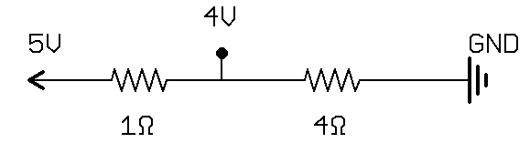 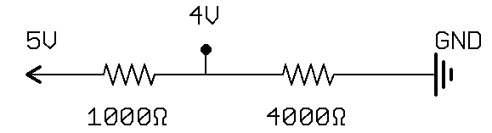  
  A: the current in the circuit would be much smaller.

|  |  |
| --- | --- |
| * Add a push button to connect the LED and 220 ohm resister directly 5V. How does the brightness compare to powering it from the voltage divider | *C:\Users\Harryp\MEGA\Surface Pro 2\Nepal\Himalayan Makers Guild\Activities\Foundation Activities\FA11 - Voltage Divider Night Light\images\Eagle\nightlight_button.png* |
| * How many nodes are there in the circuit? A: four nodes. |  |

Frequently Asked Questions

* The student thinks the circuit isn’t working because the light isn’t turning on.  
  A1: clarify that in a bright room, we want the light off. To imitate being in a dark room, the student should cover the LSR with their finger, then the LED should turn on.  
  A2: check the polarity of the LED and make sure that the (+) side is connected towards the Arduino pin, and (-) is connected to GND.   
  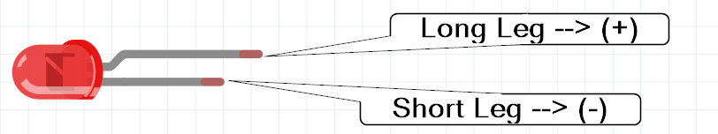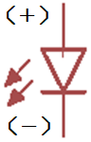
* Circuit looks good, LED polarity is correct, but it’s still not working.  
  A1: Make sure the power supply is on and on the breadboard in the correct direction with the (-) from the power supply on the blue line of the breadboard:  
  CORRECT:  
  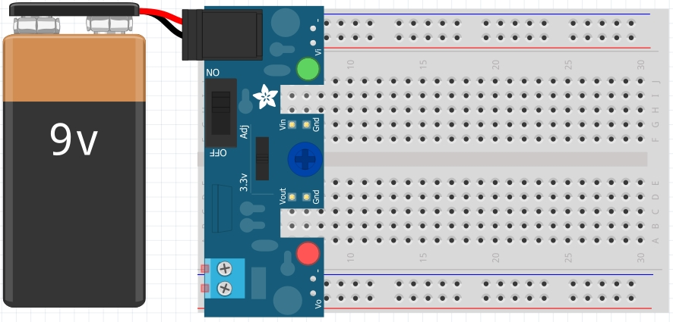  
  INCORRECT:  
  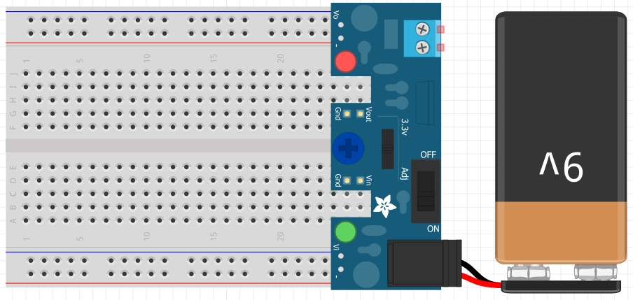  
  A2: check to make sure the LED isn’t burnt out by trying it in a friend’s circuit that is already working.  
  A3: the resistor in the voltage divider may be too large for the light conditions of the room, and the voltage in the divider is not rising high enough to switch on the light. Try a smaller resistor value in the voltage divider (put a 2nd 22kΩ resistor in parallel with the first to lower the total resistance to 11kΩ).
* The LED is on all the time, and just changes brightness when the LSR is covered (gets dimmer).  
  A1: The student connects all of the components in series. Have them try drawing the circuit diagram of the circuit they’ve built, and compare it to the night-light circuit.  
  A2: The resistor in the voltage divider may be small for the light conditions of the room, so the voltage never gets low enough to switch the light off. Try increasing the resistance.

1. Sun and moon icons made by Freepik from www.flaticon.com [↑](#footnote-ref-1)